# Unit: ITSFT -406-1504

## Programming for Computer Games - Home Assignment 1

## Designing and creating a basic 2D game

**Question 1 (AA1, AA2):**

1. Game Engines: Unity and Construct

I’ll be using unity as my ideal game engine. Some reasons on how I picked up the game engine are:

1 – While Construct is user friendly, it’s very limited scripting wise. Unity offers the usage of high-level languages such as C# which can be used to further customise your project. From physics on objects, collision, animation, and much more.

2 – Unity boasts an optimised game engine (Determine whether your game is CPU or GPU-bound) which can work smoothly on older systems. In contrast, construct can potentially have performance issues on intensive games.

3 – Unity works with 3rd party IDEs. It’s not restricted/limited to its own program. This allows users to program with their preferred IDE like Visual Studio.

4 – Unity offers support on a plethora of platforms (25+). From mobile, television, to even virtual/augmented reality.

1. Programming Languages: C# and JavaScript

For this assignment project, I’ll be using C# to further familiarise myself with the language and improve on it. Some features of C# are:

1 – It’s Object Oriented. When developing with C#, object oriented makes maintaining and improving your project more fluid.

2 – It’s a modern, general-purpose programming language which is derived from C++ and Java.

3 – Compatible. Developed with the .NET language, it allows support with other language structures that support .NET framework.

4 – C#’s Rich Library. This allows the use of inbuilt functions to make a more efficient, and faster development cycle.

**Question 2 (SE1):**

1. State Diagram – Overview

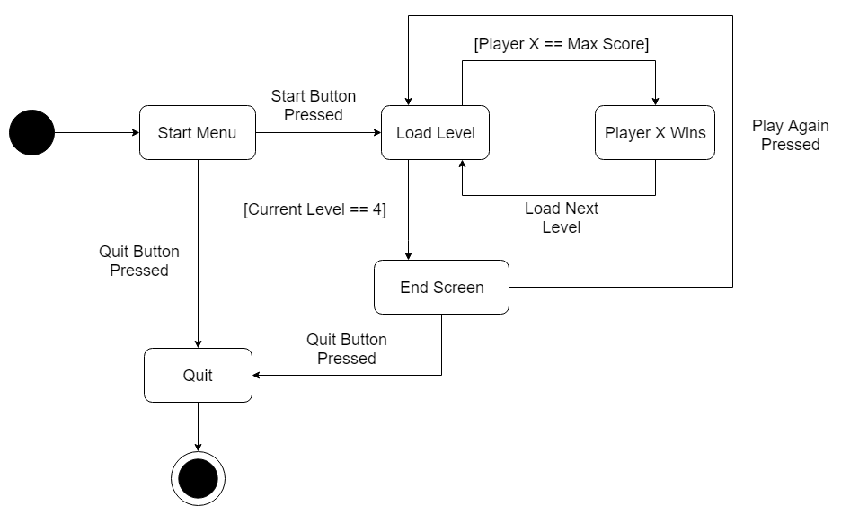

1. Detailed State Diagram – Level 2

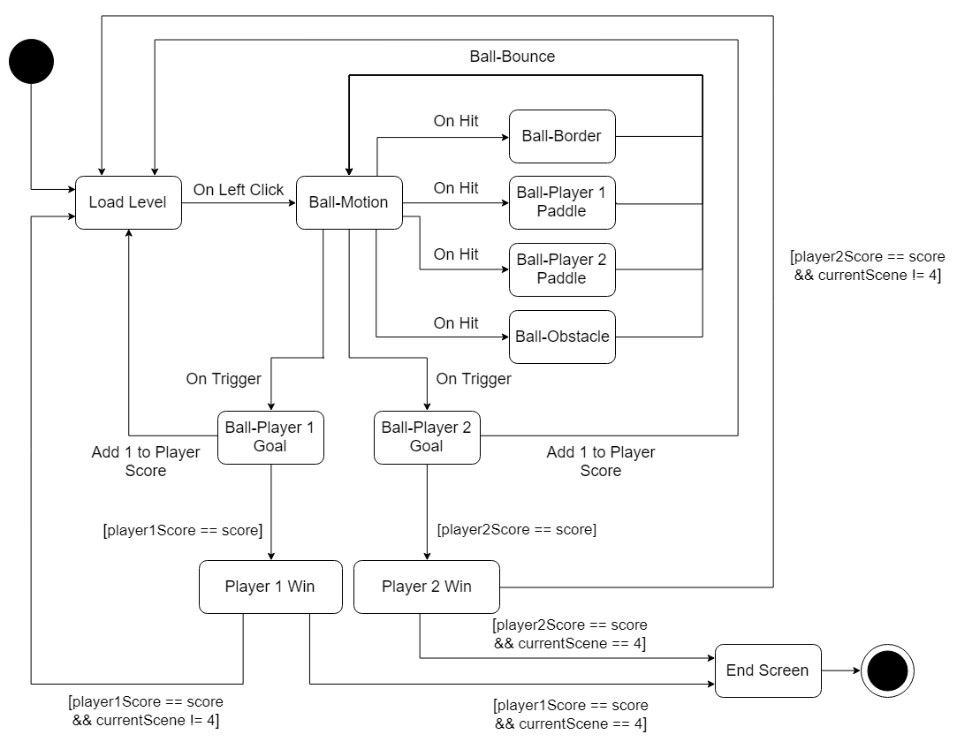

**Question 3 (KU 4):**

When using media assets, one must keep in mind the loading speed, size, and overall optimization. That’s where compression comes into play. When you’re compressing assets, you’re encoding data using fewer bits. This can be done by eliminating unnecessary resources/data. However, compression is not so simple. There are several compression methods and algorithms that need to be taken in consideration for the best compression.

For images, one must consider; format, screen resolution, vector vs raster, and much more if you want the best optimization (Ex. PNG). For videos and audio, it’s quality vs space. For instance, format is extremely important if you don’t want longer load times (Ex. Mp3). This comes at the cost of dropping video quality. Balance must be taken into consideration for best compression without losing quality.

<https://developers.google.com/web/fundamentals/performance/optimizing-content-efficiency/optimize-encoding-and-transfer>

<https://www.lifewire.com/what-is-media-file-compression-1847431>